FOR IMMEDIATE RELEASE
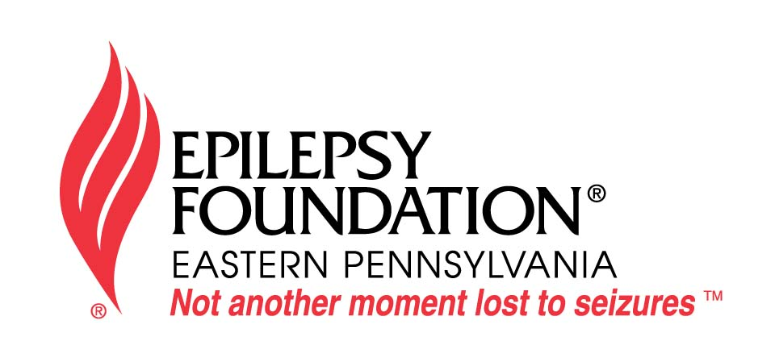

Epilepsy Foundation Eastern PA
919 Walnut Street, Suite 700
Philadelphia, PA 19107
www.efepa.org

Contact:

Madeline Bergman
(215) 629-5003, ext. 106

November is National Epilepsy Awareness Month…It’s Time to Get Seizure Smart!
Epilepsy Foundation Eastern Pennsylvania Joins Nationwide Effort to Raise Awareness about Epilepsy

Pennsylvania – This November, in recognition of November Epilepsy Awareness Moth, the Epilepsy Foundation Eastern PA joins a national movement to bring awareness to what a seizure is and is not. The goal of the campaign is to educate Pennsylvanians about epilepsy, seizure recognition and seizure first aid.
“It is estimated that 109,000 people living in eastern PA have epilepsy, yet many people have serious misperceptions about how to recognize seizure symptoms and provide the right kind of aid,” said Allison McCartin, Executive Director of the EFEPA. “This month, we are joining organizations around the country to raise awareness about the importance of epilepsy education.”

During the month of November, the Foundation will host a series of seizure awareness events to educate the local community, including an Epilepsy Education and Information Exchange on Saturday, November 12th at the ACE Conference Center in Lafayette Hill. The purpose of the program is to educate individuals living with epilepsy and their caregivers. Topics will include current information about epilepsy/seizure disorder, treatments and quality of life issues, and psychological aspects of the disorder. Other events will extend throughout the organization’s 18-county service area, including a support group run bowling fundraiser, “Strike Out for Epilepsy” in Wilkes-Barre and a new Young Adults Epilepsy group in Lancaster. This unique support group is open to anyone age 14 to 22, who is affected by epilepsy.

The EFEPA will distribute educational resources throughout the community to schools, churches, gyms and restaurants through their public education campaign. In addition, posters will be aboard SEPTA’s Regional Rails and local store windows and buildings will be decorated in lavender, the international color of epilepsy. Buildings and landmarks in Philadelphia will also be lit lavender in honor of this month, including both Liberty Places, the National Constitution Center, the Cira Center, Strawberry Mansion Bridge, Philadelphia Police Headquarters and the Ben Franklin Bridge.

The Foundation challenges all Pennsylvanians to “Get Seizure Smart” by learning how to identify a seizure and know how to respond when someone is having a seizure. The Foundation’s website (www.efepa.org) and Facebook page, delivers tools to help people spread the word about National Epilepsy Awareness Month. It features an interactive quiz, seizure first aid fact sheets, a calendar of awareness month events and other resources.

“National Epilepsy Awareness Month is set aside to focus attention on the nearly 3 million people impacted by epilepsy,” said McCartin. “Epilepsy Foundation Eastern Pennsylvania is one of nearly 50 Epilepsy Foundations working to improve the quality of life for people with epilepsy in local communities.” When a person has two or more unprovoked seizures, they are considered to have epilepsy. A seizure is an abnormal electrical discharge in the brain. Seizures can be caused by head injuries, lack of oxygen at birth, brain tumors and other health conditions. This year, another 200,000 people in our country will be diagnosed with epilepsy. To date, there is no known cure and for 70 percent of all cases there is no known cause.

For more information about epilepsy, or National Epilepsy Awareness Month activities, please visit www.efepa.org or call 215.629.5003.

###

The Epilepsy Foundation Eastern Pennsylvania is the only organization in the area that addresses the non-medical issues and needs of those with epilepsy/seizure disorder through education, support and advocacy. The late Charley Roach of Prudential, Fox, Roach Realtors, was instrumental in founding the organization in 1972 to provide local resources and information about this misunderstood neurological disorder.

