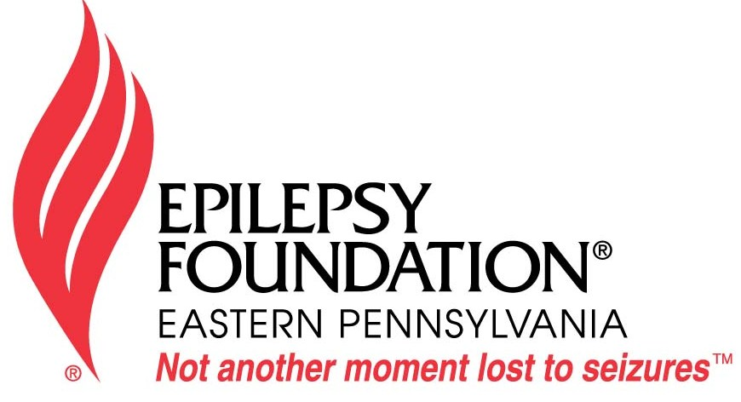

Date:

[Insert contact’s address]
[Insert city, State]
[Insert zip code]

Dear [Insert name of editor]:
Nearly 3 million Americans have epilepsy, yet the public is largely unaware how prevalent it is and how serious of a condition it is without proper treatment and first aid knowledge. November is National Epilepsy Awareness Month, and I am working with the Epilepsy Foundation Eastern PA to raise awareness of this condition.
Epilepsy is common; there are 109,000 people with epilepsy in eastern PA. Many people cannot properly recognize or do not know what to do when someone has a seizure. Most people do not realize a seizure is not always convulsive; there are many different types of seizures. If you see someone having a convulsive seizure, you should turn them on their side and cushion their head. Do not put anything in their mouth. Be sure to time the seizure and call 911 if the seizure lasts longer than five minutes. Epilepsy is not contagious and seizures are not dangerous to anyone witnessing one. To learn more about different types of seizures and first aid treatment, visit www.efepa.org/living-with-epilepsy.
As someone affected by epilepsy, I strongly encourage everyone to get educated by visiting www.efepa.org. My life, or that of someone you know, may depend on it.

[Insert your name]
[Insert your address]
[Insert daytime telephone number]

Letter to the Editor

