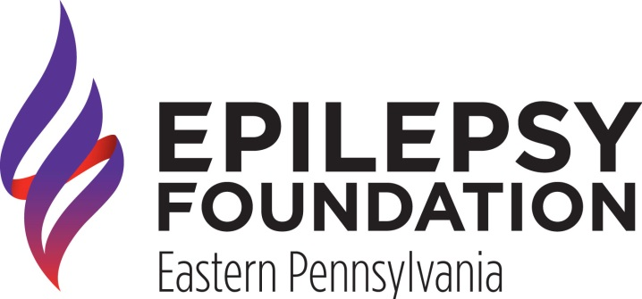
Media Contact:
Marikate Taylor
Information & Communications Coordinator
215-629-5003 x.106 | mtaylor@efepa.org

Epilepsy Foundation Eastern PA to host Annual Conference
Keynote Session, “Weeding out the Truth: Medical Marijuana and Epilepsy”

November 1, 2014 |Philadelphia, PA; The Epilepsy Foundation Eastern Pennsylvania (EFEPA) is proud to offer it’s annual Epilepsy Education Exchange, a free conference that explores the latest in epilepsy research, treatment options and future of the field. The program is set to take place on November 1, 2014 at the ACE Conference Center in Lafayette Hill, PA. The conference kicks off November as Epilepsy Awareness Month, a nationwide effort to bring greater understanding of seizure disorders.

The keynote session this year is “Weeding out the Truth: Medical Marijuana and Epilepsy,” presented by Dr. Eric Marsh from the Regional Epilepsy Center at the Children’s Hospital of Philadelphia and Dr. Joyce Liporace of Great Valley Neurologic Associates. The session is an extension of the EFEPA’s support of decreasing restrictions on medical marijuana for further research and clinical trials so that all individuals can have equal access to potentially life-saving treatment. The session will be crucial for attendees who include patients with epilepsy, their caregivers and health professionals to learn more about the viability of medical marijuana as a potentially life-saving treatment option. By becoming more educated on the subject constituents will become empowered to advocate for their needs on a local or national level. Additionally, Dr. Dennis Dlugos from the Children’s Hospital of Philadelphia will hold a smaller workshop session titled, “What the Medical Marijuana Hub-Bub tells us about Present and Future Epilepsy Treatments” to further explore the subject.

Additional workshops include “New Treatment Devices and Clinical Trials,” with Kathryn Davis, MD of the Penn Epilepsy Center, “Headaches & Epilepsy,” with Stephanie Wrobel Goldberg from the Jefferson Headache Center and “Caregiver Stress,” presented by Dr. Jaime Spinnell Zuckerman, PsyD. These workshops cover a wide range of subjects in order to address the different ways epilepsy can impact one’s life.

“Epilepsy can be incredibly frightening, particularly for individuals with uncontrolled seizures. All too often they lose hope that they will never be able to live above their diagnoses and enjoy life the fullest,” explains Allison McCartin, the Executive Director of the EFEPA. “But by providing the information on the latest in and future of the filed, we can inspire hope that you can have access to all that life has to offer and have epilepsy.”

The Epilepsy Education Exchange is the only kind of program in the area for the estimated 110,000 individuals in eastern PA diagnosed with epilepsy. The program begins promptly at 9:00 am with the keynote session and concludes by 1:00 pm. Vendors will be onsite offering additional information to attendees. Past vendors include Canine Partners for Life, Cyberonics, Inc., UCB Pharmaceuticals, Eisai Pharmaceuticals, and Lundbeck Pharmaceuticals. Opportunities for sponsorship or vendor tables are still available. The EFEPA projects over 200 individuals will attend the program.

To register visit www.epilepsyexchange.org. To learn more about the EFEPA and the free programs and services we offer visit our website www.efepa.org.

