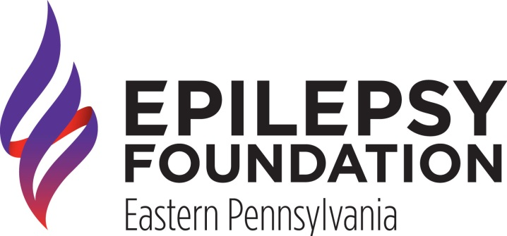
Contact:
Mary Loughlin
Northeast Resource Coordinator
570-592-1150 | epilepsywv@efepa.org

Epilepsy Foundation Eastern PA to host Annual Conference

October 7, 2015 |Wilkes-Barre, PA; The Epilepsy Foundation Eastern Pennsylvania (EFEPA) is proud to offer it’s Northeastern PA Epilepsy Education Exchange, a free conference that explores the latest in epilepsy research, treatment options and future of the field. The program is set to take place on October 21, 2015 at the John Heinz Institute in Wilkes-Barre, PA. It is free and open to the public.

State Representative Tarah Toohill will deliver the opening remarks, followed by a panel of speakers discussing various aspects of living with epilepsy. We’re excited to host a panel of experts who can help you learn more about school, employment, establishing independence and Social Security benefits. Panelists include Mary Jane Saras, LCSW, Coordinator Office of Vocational Rehabilitation (OVR); Diana Morris Smaglik, Anthracite Region Center for Independent Living (ARCIL); and Michael Parker, Esq. Pond Lehocky Stern Giordano.

“Epilepsy can be incredibly frightening, particularly for individuals with uncontrolled seizures. All too often they lose hope that they will never be able to live above their diagnoses and enjoy life the fullest,” explains Allison McCartin, the President and CEO of the EFEPA. “But by providing the information on the latest in and future of the filed, we can inspire hope that you can have access to all that life has to offer and have epilepsy.”

The Epilepsy Education Exchange is the only kind of program in the area for the estimated 11,800 individuals in northeastern Pennsylvania diagnosed with epilepsy. Registration opens at 5:30 pm and the program will begin promptly at 6:00 pm. Vendors will be onsite offering additional information to attendees. Past vendors include UCB Pharmaceuticals, Lundbeck Pharmaceutical, Cyberonics, and OVR. Opportunities for sponsorship or vendor tables are still available. The EFEPA anticipates over 75 people will attend.

To register visit www.epilepsyinthevalley.org. To learn more about the EFEPA and the free programs and services we offer visit our website www.efepa.org.

